

***Spring Framework***

**Training Assignments**

|  |  |
| --- | --- |
| Document Code | 25e-BM/HR/HDCV/FSOFT |
| Version | 1.1 |
| Effective Date | 20/11/2012 |

**Hanoi, 06/2019**

RECORD OF CHANGES

|  |  |  |  |  |  |
| --- | --- | --- | --- | --- | --- |
| No | Effective Date | Change Description | Reason | Reviewer | Approver |
|  | 01/Oct/2018 | Add the new labs | Create new | DieuNT1 | VinhNV |
|  | 01/Jun/2019 | Update template | Fsoft template | DieuNT1 | VinhNV |
|  |  |  |  |  |  |
|  |  |  |  |  |  |
|  |  |  |  |  |  |
|  |  |  |  |  |  |
|  |  |  |  |  |  |
|  |  |  |  |  |  |
|  |  |  |  |  |  |
|  |  |  |  |  |  |

Contents

Objectives 4

Business needs 4

Working Environments 5

Product Architecture 5

Technologies 5

Database Relationships 6

Assignment Descriptions 7

|  |  |
| --- | --- |
|  | **CODE: JSFW.L.A101 (AIPO)**  **TYPE: LONG**  **LOC: N/A**  **DURATION: 360 MINUTES** |

# **Objectives**

After finishing the following exercises, trainees will:

* Understand Spring Core (IoC, DI)
* Practice with JDBC Templates to connect database in spring
* Use JPA for object-relational mapping
* Practice with the Spring MVC framework architecture
* Know how to write a Web application with Spring MVC Framework and Spring Data JPA

# **Business needs**

Create a Web application bases on HTML, CSS, JavaScript, Ajax, Servlet, JSP, Spring framework.

AIPO is an open source system to user can use service or get source to develop. Some service in AIPO:

* Todo: You can organize the task
* Schedule: You can manage the day to day schedule
* News: The company will spread to the outside of the information
* Blog: You can share the know-how

You can access to https://www.aipo.com/ to more detail

In this assignment, we will create some page to manage user which use AIPO system. We will develop a little part in this system. Below, Use case diagram for this system:

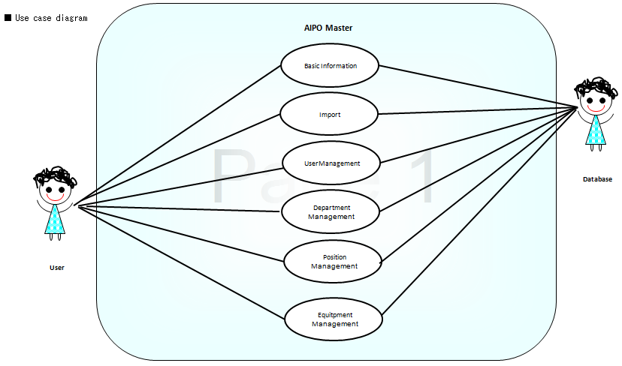

# Working Environments

* JDK 1.8 +
* Maven 3+
* Eclipse IDE or STS,
* MySQL DB Server/MySQL,
* Apache TomCat 7 or later,
* Internet connection,

Delivery: Source code, deployment and testing, reviewing evidences packaged in a compress archive.

# Product Architecture

Web applications are by nature distributed applications, meaning that they are programs that run on more than one computer and communicate through a network or server. Specifically, web applications are accessed with a web browser and are popular because of the ease of using the browser as a user client.

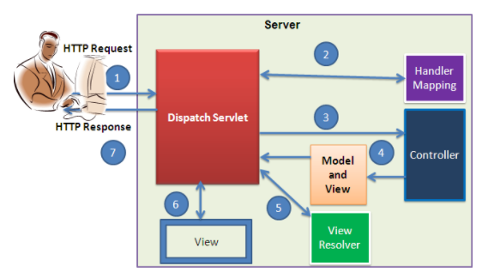

The product is implemented using MVC Pattern base on Spring Web MVC.

# Technologies

The product implements one or more technology:

* HTML & CSS
* JavaScript & Ajax
* MVC & JSP Model
* Spring Framework: IoC, Bean, SpEL, JdbcTemplate, Spring Data JPA, Interceptor, Validation, Spring Sercutity

# Database Relationships

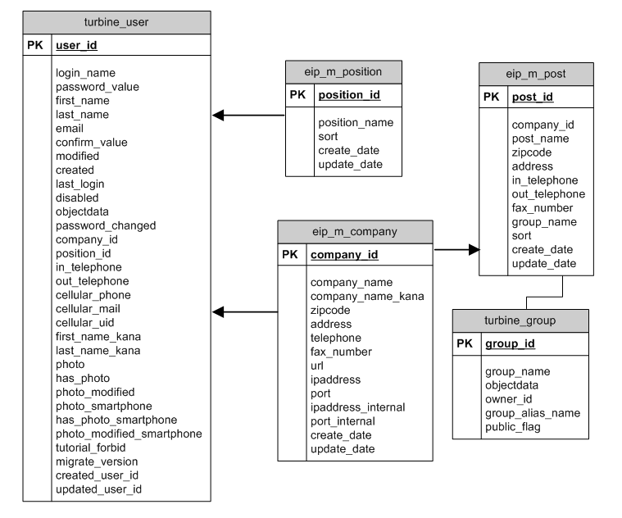

* We will create 5 tables named, they are turbine_user, turbine_group, eip_m_post , eip_m_position, eip_m_company
* Relationship:
  + turbine_user. company_id = eip_m_company. company_id(N:1)
  + turbine_user. position_id = eip_m_position. position_id(N:1)
  + eip_m_company. company_id = eip_m_post. company_id(1:N)
  + eip_m_post. group_name = turbine_group. group_name(1:1)

Scripts to create 5 tables in **create_table.txt**.

# Assignment Descriptions

1. ***Create the pages as below:***

* Index page:

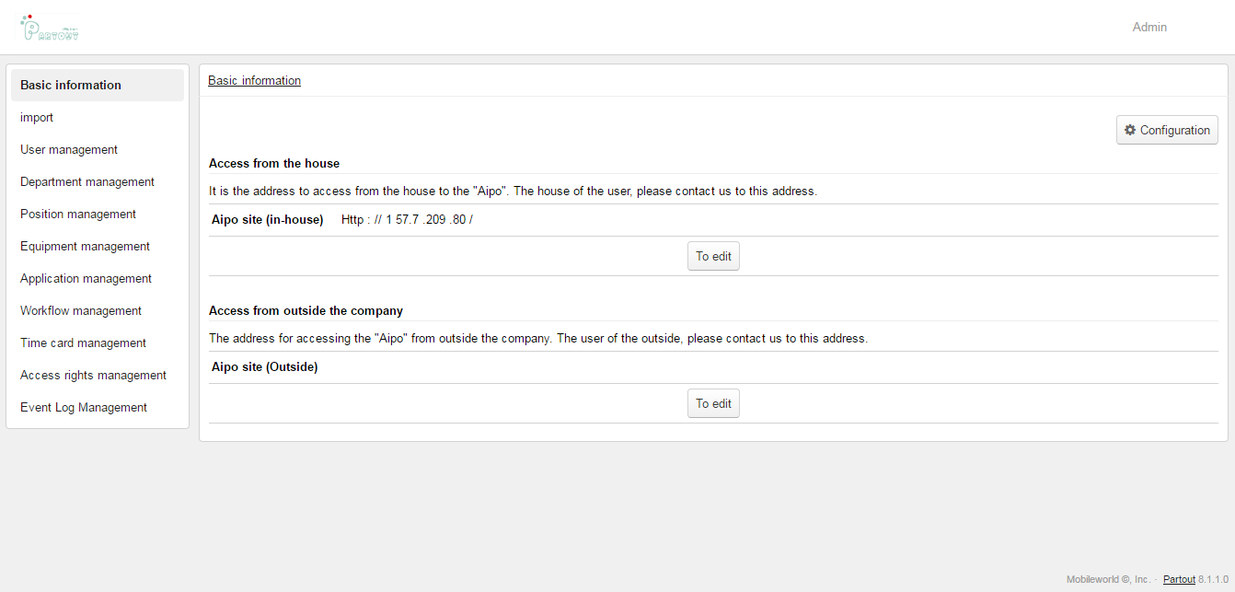

* Search User page:

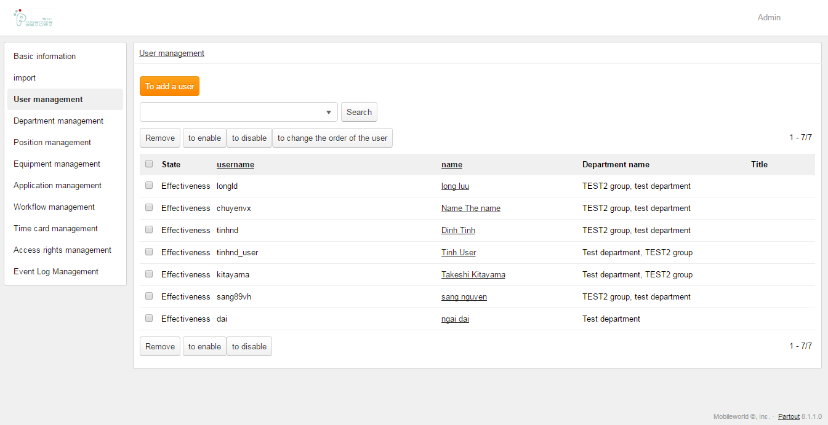

­Screen Item:

|  |  |  |  |  |  |
| --- | --- | --- | --- | --- | --- |
| **No** | **Items** | **Type** | **Size** | **Table.Item** | **Comment** |
| 1 | AddUser | Button | NA | NA |  |
| 2 | Search | Combobox | NA | NA |  |
| 3 | BTNSearch | Button | NA | NA |  |
| 4 | Remove | Button | NA | NA |  |
| 5 | Enable | Button | NA | NA |  |
| 6 | Disable | Button | NA | NA |  |
| 7 | Change | Button | NA | NA |  |
| 8 | CheckUser | Checkbox | NA | NA | List |
| 9 | UserName | Lable | 30 | turbine_user.login_name | List |
| 10 | Name | Lable | 50 | turbine_user.last_name & " "& turbine_user.first_name | List |
| 11 | Department | Lable | 50 | eip_m_post.post_name | List |

* Add User page:

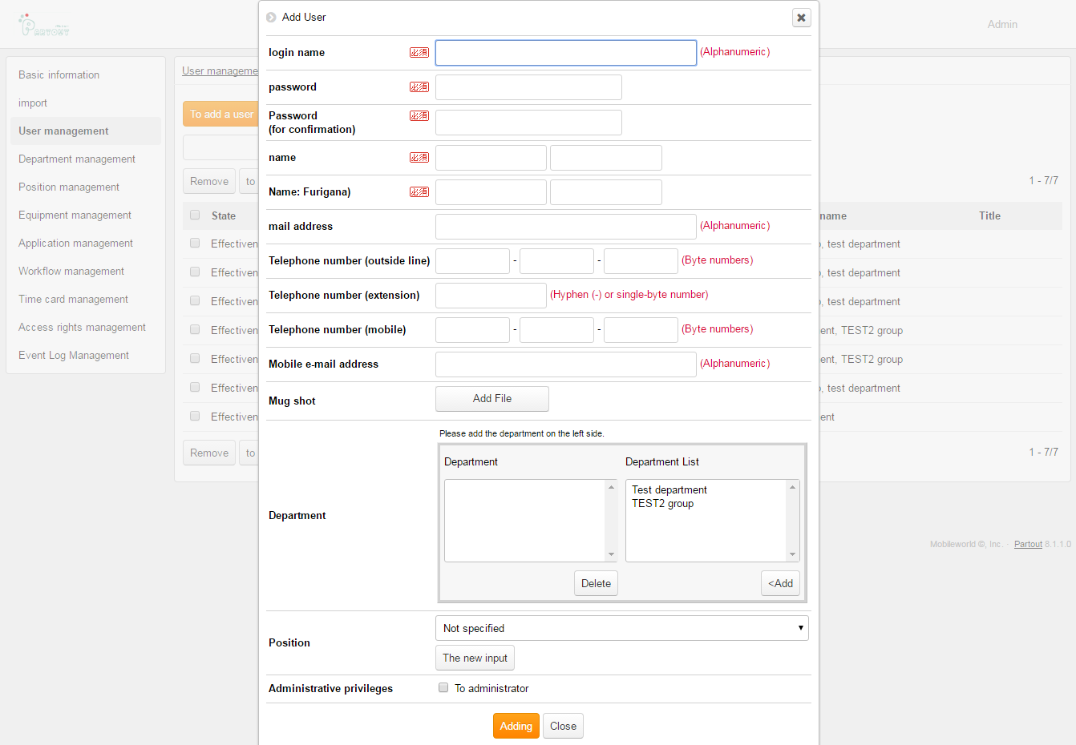

Screen items:

|  |  |  |  |  |
| --- | --- | --- | --- | --- |
| **No** | **Items** | **Type** | **Size** | **Table.Item** |
| 1 | LoginName | Textbox | 32 | turbine_user.login_name |
| 2 | Password | Password | 20 | turbine_user.password_changed |
| 3 | PasswordConfirm | Password | 20 | NA |
| 4 | FirstName | Textbox | 99 | turbine_user.first_name |
| 5 | LastName | Textbox | 99 | turbine_user.last_name |
| 6 | FirstNameKana | Textbox | 99 | turbine_user.first_name_kana |
| 7 | LastNameKana | Textbox | 99 | turbine_user.last_name_kana |
| 8 | Email | Mail | 99 | turbine_user.email |
| 9 | OutTelephone | Textbox | 15 | turbine_user.out_telephone |
| 10 | InTelephone | Textbox | 15 | turbine_user.in_telephone |
| 11 | CellularPhone | Textbox | 15 | turbine_user.cellular_phone |
| 12 | CellularMail | Textbox | 99 | turbine_user.cellular_mail |
| 13 | Photo | Upload | NA | turbine_user.photo |
| 14 | Department | Listbox | NA | eip_m_post.post_name |
| 15 | PositionId | Combobox | NA | turbine_user.position_id |
| 16 | IsAdmin | Checkbox | 1 | turbine_user.is_admin |

1. **Screen Requirement:**

* Let design based on the screen illustrate.
* Add User must be a popup.
* Placeholder text in inputs has a light gray color. You need to define the placeholder for input items on the same above screen.
* Add a new file fStyle.css to customize your screen, it will be based on convention of CSS style.
* The **Index** page must contain 3 parts: Banner, Menu, Body

1. **Functional Requirement:**

* In this assignment you will create a program that allows user to input in Create User page and show data in Search User page.
* Use Case:

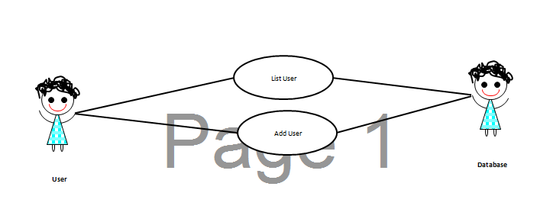

* Fill data for combo box of position item and List of Department item in Create User Page
  + In Create User Page, you will insert user information to database.
* In Search User Page, you will select data from database, and show data in screen when user choose from list in Search combo box or input after click Search button
  + Fill data to Search combo box in Search User Page

**-- THE END --**